# Fatherhood

# **Statewide Training**

# With **Sidney Moncrief**

****FREE**

***THE ARKANSAS FATHERHOOD and FAMILY INITIATIVE:***

Fathers Engaged and Empowered to Learn (FEEL) is to strengthen family foundations and reverse

the absentee fatherhood trend by helping fathers to understand the challenges of parenting as

well as increase skills in building and maintaining healthy relationships.



Coach Sidney Moncrief will give fathers the skills to increase self-awareness as a man in order to develop as a father, make an earnest effort toward responsible fatherhood, build confidence as a man and as a parent, and more.



**\*april 25, 2015**

Children’s Hall East Campus

Arkansas Children's Hospital   
1 Children's Way   
Little Rock, AR 72202-3591

**\*may 2, 2015**

Wyatt Baptist Church

4621 West Hillsboro

El Dorado, Arkansas  71730

**\*may 16, 2015**

Washington 4A Charter School

1900 Marietta

Texarkana, AR 71854

**\*may 30, 2015**

MCAEOC Wiley Center

1007 S. Franklin St

Blytheville, AR 72315

**\*june 6, 2015**

Yvonne Richardson Community Center

240 E. Rock Street

Fayetteville, AR 72701

***All trainings are from 9:00 am-1:00 pm***

For more information, please contact

The Head Start State Collaboration Office

1400 W. Markham, Suite. 406

Little Rock, AR 72201

501-371-0740

***Please go online at*** [***www.arheadstart.org***](http://www.arheadstart.org) ***to register or complete the registration form on the reverse side of this flyer and mail to the address above.***

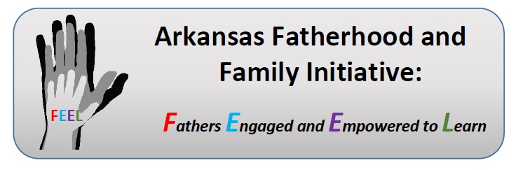

**REGISTRATION FORM**

**Name:** \_\_\_\_\_\_\_\_\_\_\_\_\_\_\_\_\_\_\_\_\_\_\_\_\_\_\_\_\_\_\_\_\_\_\_\_\_\_\_\_\_\_\_\_\_\_\_\_\_\_\_\_\_\_\_\_\_\_\_\_\_\_\_\_\_\_\_\_\_\_\_\_\_\_

**Address**:\_\_\_\_\_\_\_\_\_\_\_\_\_\_\_\_\_\_\_\_\_\_\_\_\_\_\_\_\_\_\_\_\_\_\_\_\_\_\_\_\_\_\_\_\_\_\_\_\_\_\_\_\_\_\_\_\_\_\_\_\_\_\_\_\_\_\_\_\_\_\_\_\_

**City/State**:\_\_\_\_\_\_\_\_\_\_\_\_\_\_\_\_\_\_\_\_\_\_\_\_\_\_\_\_\_\_\_\_\_\_\_\_\_\_\_\_\_\_\_\_\_\_\_\_\_\_\_\_\_\_\_\_\_\_\_\_\_\_\_\_\_\_\_\_\_\_\_

**Contact Info**:\_\_\_\_\_\_\_\_\_\_\_\_\_\_\_\_\_\_\_\_\_\_\_\_\_\_\_\_\_\_\_\_\_\_\_\_\_\_\_\_\_\_\_\_\_\_\_\_\_\_\_\_\_\_\_\_\_\_\_\_\_\_\_\_\_\_\_\_\_\_\_

**Organization:** \_\_\_\_\_\_\_\_\_\_\_\_\_\_\_\_\_\_\_\_\_\_\_\_\_\_\_\_\_\_\_\_\_\_\_\_\_\_\_\_\_\_\_\_\_\_\_\_\_\_\_\_\_\_\_\_\_\_\_\_\_\_\_\_\_\_\_\_\_\_

**Age of Children**: \_\_\_\_\_\_\_\_\_\_\_\_\_\_\_\_\_\_\_\_\_\_\_\_\_\_\_\_\_\_\_\_\_\_\_\_\_\_\_\_\_\_\_\_\_\_\_\_\_\_\_\_\_\_\_\_\_\_\_\_\_\_\_\_\_\_\_\_\_

**Registration Deadline: April 10, 2015 Please fax or email registration forms to: 501-370-9109**

**Please select one of the following:**

\_\_ Saturday April 25, 2015-Little Rock, AR

\_\_ Saturday May 2, 2015-El Dorado, AR

\_\_ Saturday May 16, 2015-Texarkana, AR

\_\_ Saturday May 30, 2015- Blytheville, AR

\_\_ Saturday June 6, 2015-Fayetteville, AR

hEADSTART COLLABORATION OFFICE

1400 w. MARKHAM, STE. 406

lITTLE ROCK, AR 72201

501-371-0740

\*\*\*\*\*\*\*\*\*\*\*\*\*\*\*\*\*\*\*\*\*\*\*\*\*\*\*\*\*\*\*\*\*\*\*\*\*\*\*\*\*\*\*\*\*\*\*\*\*\*\*\*\*\*\*\*\*\*\*\*\*\*\*\*\*\*\*\*\*\*\*\*\*\*\*\*\*\*\*\*\*\*\*\*\*\*\*\*\*

***The Arkansas Fatherhood & Family Initiative: Fathers Engaged and Empowered to Learn (FEEL) is to strengthen family foundations and reverse the absentee fatherhood trend by helping fathers to understand the challenges of parenting as well as increase skills in building and maintaining healthy relationships.***

**All trainings are free!**

***ahsa_kids.tif***